The Importance of Personal Branding in Digital Marketing

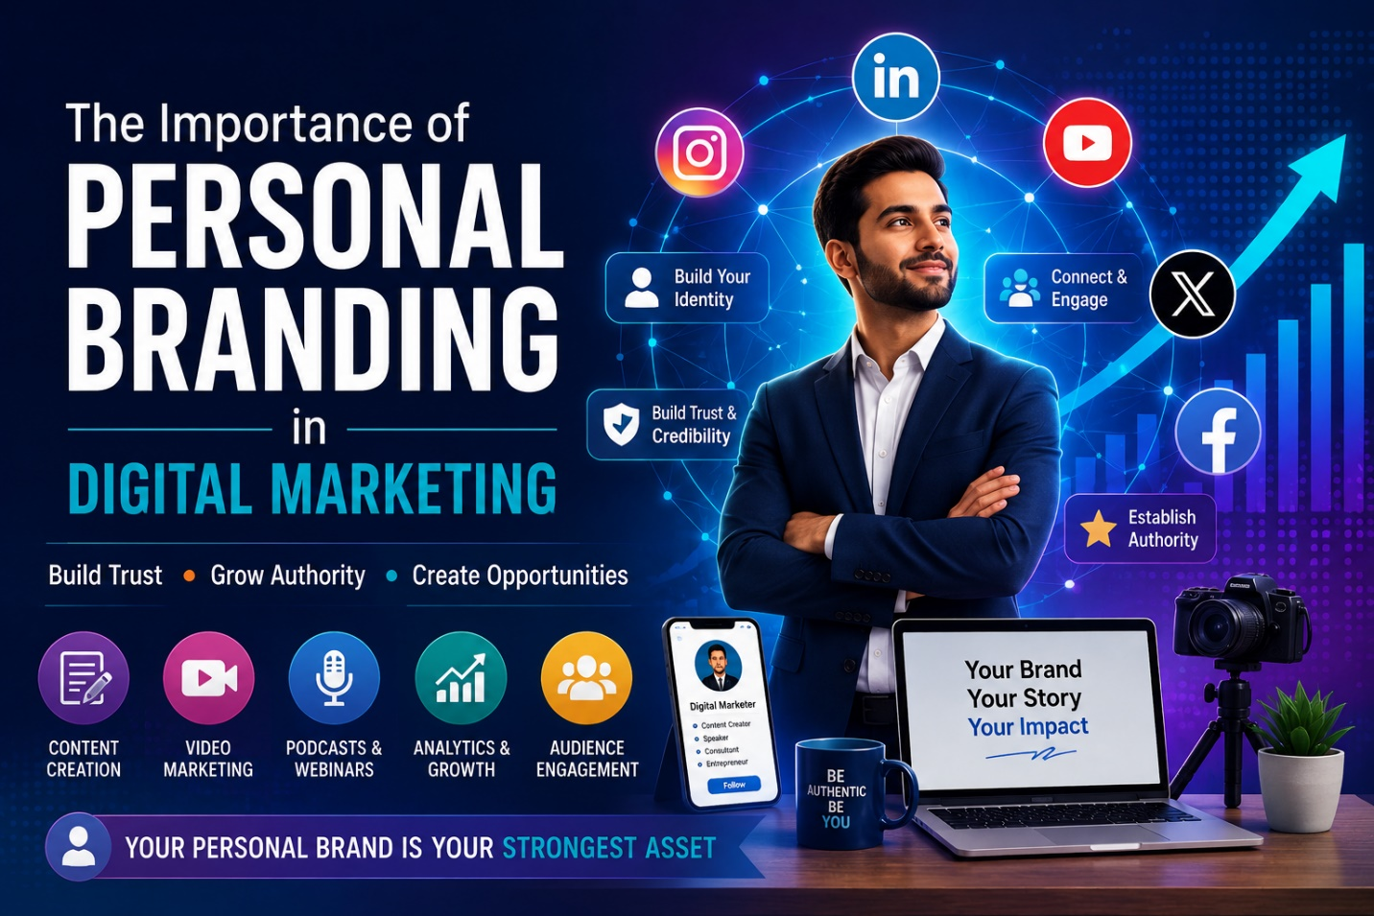
In the highly connected modern world, one of the most effective tools available to individuals is personal branding, whether you are an entrepreneur, a person of influence, a freelancer, a corporation, or anything else for that matter. Having an established online reputation will play a key role in the success of your work. You cannot afford to exist but rather be known and respected merely. Personal branding is an essential aspect of digital marketing today.
The simple reason behind this is the fact that personal brands allow trust and relationship building. In the modern world of highly active social media websites such as Twitter and Facebook, alongside blogs, podcasts, and video content, it is easier for people to connect with a person than a company.

Definition of Personal Branding
Personal branding is defined as the phenomenon that involves building an identity that describes what one is skilled at or has as his or her professional personality. With the current digital era, personal branding makes one create an identity. It is through personal branding that individuals are branded by others. Personal branding makes one's professional and personal attributes come out.
When it comes to digital marketing, personal branding is the ability to create an identity on platforms like LinkedIn, Instagram, YouTube, X, Facebook, and personal websites. Information, how it is disseminated, its value, and how it is depicted visually matter in this context.
For example, those who continue sharing their thoughts on topics about digital marketing end up becoming specialists in the concerned domain.

Personal Branding in Digital Marketing
Builds Trust and Credibility
In addition to many other things, there is yet another important element that is associated with digital marketing. This element is none other than building up trust. It is very easy for you to relate to those individuals and companies who have credibility.
By providing credible information and boasting of your successes, and by having authentic interaction with your clients, you would be able to gain their trust in your capabilities in digital marketing.
If you desire a career in digital marketing, then the right place to register yourself for is the Digital Marketing Classes in Bangalore.

Makes It Easier to Stand Out from Other Competing Brands
Marketing through the internet is highly competitive. There are many businesses competing with each other. By means of personal branding, one is able to differentiate oneself from the rest.
Whereas traditional marketing is mainly concerned with the products offered, personal branding is about marketing oneself. People relate more to personal brands; thus, it is more influential when it comes to making decisions.
Take, for example, two businesses are providing similar services. The business that has an expert whose name is known will gain precedence over the others.

Enhances Online Visibility

A strong personal brand improves your online visibility through search engines and social media platforms. Regularly publishing high-quality content, participating in discussions, and engaging with audiences increases your digital footprint.
Search engines prioritize relevant and valuable content, which means a strong personal brand can improve search rankings and attract more organic traffic. This visibility helps professionals and businesses gain recognition in their industry.
Platforms like LinkedIn and YouTube are particularly effective for building authority. Sharing educational content, case studies, and industry updates helps position you as a thought leader.

Branding Yourself via Social Media
Concerning personal branding, one shouldn't forget about social media websites that allow one to interact directly with his/her followers, demonstrate their own skills, and create an audience based on their personal brand.
Enhancing Personal Professional Image through LinkedIn
Of all social media websites currently existing, LinkedIn is the best website for enhancing one's professional image. Here, one can demonstrate achievements and personal experience in a specific profession or career path.
Involving the Audience via Instagram & Facebook
Facebook and Instagram may be used when talking about involving the audience and sharing one's own experience. All features of Instagram and Facebook will assist one in establishing stronger interaction with his/her audience.
Becoming an Industry Leader by Posting Videos
It is essential not to ignore posting videos when talking about building a personal brand. One should use YouTube to post videos concerning how to succeed in some industry or niche.

Personal Branding and Content Marketing
Personal branding works together with content marketing, which is equally important for ensuring successful performance online. Content marketing is helpful when it comes to proving expertise on some topics and attracting those people who are interested in the discussed topic.
Such examples of content marketing are the following:
- Blog articles
- Posts on social networks
- Videos/webinars
- Podcasts
- Newsletters
- Infographics
- Case studies
By producing useful content on the topics that are related to the industry, one gains a reputation as an authority and makes a connection with the target audience.
For instance, if a person writes articles on SEO techniques, ways of advertising, and recent news from the world of social media, they will attract many people who are interested in marketing.

The Immediate Impact of Personal Branding on Business Growth
The following is an immediate impact that personal branding has on the growth of a business:
Creates Opportunities
Good personal branding generates opportunities for individuals in terms of career opportunities, speaking engagements, collaboration initiatives, and even clients, because people always prefer to work with people who are professional and credible.
Establishes Better Connections with Consumers
It is always easier for consumers to build connections with an individual compared to a company. Personal branding facilitates such connections easily.
Improves Marketing Efforts
Personal branding helps companies market their products and services successfully because people always trust an individual more than anything else. This means that conversion rates increase.
Promotes Professional Success
Industries keep evolving, and personal branding helps professionals stay relevant and succeed in the field.

Common Problems Related to Personal Branding
Although personal branding has a lot of advantages, it comes with some problems too. They are as follows: -
Inconsistency
Consistency in your social media postings is vital. This not only involves being consistent in communicating but also in posting regularly so that your personal brand becomes effective.
Over Promotion
Promoting services and products all the time is something you should avoid. Instead of promoting, it is advised to engage your followers with your content.
Not Engaging
In personal branding, it is not only essential to publish meaningful content on social media but also to consider engaging others.
Trying to Appease Everyone
The most significant problem in personal branding is that you end up trying to appease everyone. It is better to concentrate on one specific type of person.

The Importance of Personal Branding in the Future of Digital Marketing
Even with technological progress that has happened in the sphere of digital marketing, thanks to AI and automation, personal branding will become increasingly important. New trends will arise, which will give an additional twist to digital marketing. Nevertheless, it will not change the importance of the humanity component.
The factor of authenticity is currently one of the most distinctive ones in the marketing sphere. Undoubtedly, it will be a great advantage for anyone looking to create their brand.
It can also happen that some new platforms emerge where personal branding can take place. These platforms would contain video content, live streams, and podcasts. Undoubtedly, the ones who accept this challenge and offer something unique to their audience will succeed.

Conclusion
Personal branding is an important component of digital marketing aimed at promoting individual personalities and creating trustful relations between them and their consumers. One of the ways to stand out from the crowd in the digital environment and succeed is through personal branding, which will allow building one’s reputation.
With the help of consistent content and communication with the audience, it will be possible for people to prove their credibility. Regardless of what the future brings to digital marketing, personal branding is still going to remain a relevant component.

